Geography 482/582: Advanced Digital Cartography & GIS

# Lab 1: Map Projections

Assigned date: January 30, 2020 | Due date: February 6, 2020

Total points: 40 points

## Introduction

This lab includes multiple steps of learning and practices of projections. First you will look at what is meant by on-the-fly projection transformation, or how you can change the *look* of a layer to conform to a different projection, without changing geometry of the data. Next you will examine different properties of projections to understand the types of distortions that we might encounter and how to recognize such distortions through the use of the visual aid, Tissot’s Indicatrix and understand differences between defining projection of data and projecting data.

### Part 1. On-the-fly projections change

### Download the data from Course website>Labs>Lab1 folder at BeachBoard to your USB memory.

### Open ArcMap.

One of nice features of ArcMap is that it will allow you to display projected layers “on the fly” – meaning you can overlay a layer A of a certain projection on another layer B of a different projection without changing its current projection permanently. The result is that the layer A will conform on the fly to the projected layer B’s projection (but no permanent changes are made). Let’s see how this works.

### Using “Add Data” icon in ArcMap, add a shapefile STATES from the lab data folder.

Notice the somewhat odd shape of the United States. Zoom into California, and notice how it is elongated east to west. Bring up the **Layer Properties** of the States layer (right click on the layer name in TOC, and then click Properties menu). You will notice that it has a geographic coordinate system but it does not have a projection yet.

1. At present, you have a data frame called “Layers”. Add another data frame (Insert>Data Frame), rename it as “**Projected**” by one-clicking the name two times, and add the shapefile **County** from the same folder. The County shapefile includes counties in California.

You will notice that in data view you can only see one data frame at a time as opposed to the layout view where you can put all data frames on the same page.

Notice that the “County” layer covering CA is **projected**. Check its layer properties.

|  |
| --- |
|  |
| **Question 1.** What projection coordinate system is used for this layer? **(3 points)** |
|  |

Look at the two data frames in the layout view and visually compare the shape of features between the unprojected States layer and the projected County layer.

1. Add a third data frame and rename it **County and States**. Then add the two shapefiles in this order, **County** then **States**. Make sure the States layer is under the County layer in your TOC.

Notice now that since you added a projected layer first, your unprojected layer conforms to the projection that was first used. In this case, the States shapefile layer conforms to the County shapefile layer. This is what is meant by “on-the-fly” projection. The States layer still is unprojected but is being displayed as projected. To actually project States to be in the same projection as County, you would need to use the ArcToolbox and the command, Project (Data Management). You do NOT need to perform this operation on the States layer.

To visually portray both layers you can experiment with layering and line symbology.

|  |
| --- |
|  |
| **Question 2.** Why, in the example above, is the addition of layers in a specific order important? **(5 points)** |
|  |

**Part 2. Projection and Distortion using Tissot’s Indicatrix circles**

You are going to look at ArcGlobe, which is similar to something like Google Earth.

1. Open ArcGlobe from Start>ArcGIS>**ArcGlobe** or a similar pathway.
2. Click on the earth and “drag” it around and see how you can move the earth. Position it on the United States.
3. Add the **STATES** layer and the **County** layer from Part 1. Click ‘Next’ and ‘Finish’ buttons in the Add Data Wizard for the both layers. Click ‘Close’ button to the prompt telling you there is a difference in projection information. If you do not see either of the layers added, make sure that the Imagery layer is under all other layers in the TOC in your ArcGlobe.
4. Notice that even though your STATES and County layers have different datums and different projection information, they adjust “on-the-fly” to conform to the current display, in this case, just as in Part 1.

You will load the Tissot’s Indicatrix circles on the map. Remember that the circles are reference circles and they will help us distinguish visually the type of distortion present in a projection.

1. Add a shapefile **circles_NAD83.shp** to your ArcGlobe display. Click ‘Next’ and ‘Finish’ buttons in the Add Data Wizard: circles_NAD83 window. Click ‘Close’ button to the prompt telling you there is a difference in projection information. Make sure that the Imagery layer is under all other layers in the TOC in your ArcGlobe like the example figure below.

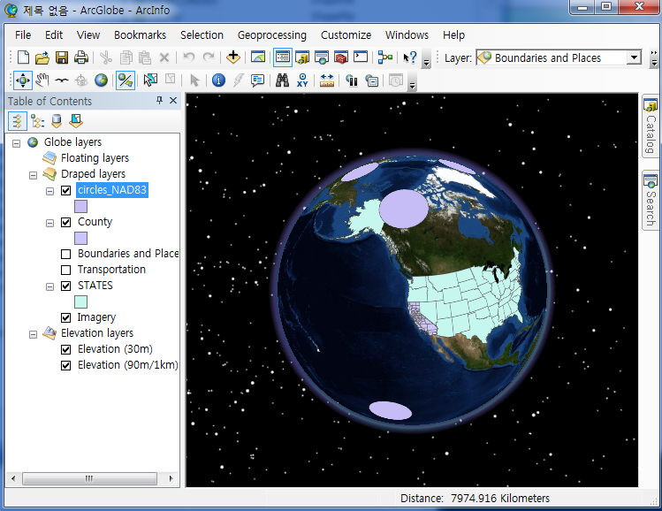

1. Rotate the earth and see the different shape of the circles in the two different shapefiles. Notice that they are all completely the same size but have different shapes when you just add them. However, the distorted circles become a perfect circle when you rotate the earth and place the circle in the middle of your globe.

You can close down ArcGlobe now and return to ArcMap

1. Open and create a new map document in ArcMap. Load the **Cntry94.shp**. From the Source tab in its Layer Properties window, notice that the data is registered to the D_North_American (NAD) 1927 datum and is in the Geographic Coordinate System (GCS).
2. Add the Tissot’s Indicatrix circles by adding the **circles.shp**. Click ‘OK’ button in the Unknown Spatial Reference window. If you need to change the color of the circles to see them more easily, do so now. Make sure that the circles layer is over Cntry94 layer in the TOC in your ArcMap.
3. Add a geographic grid to the layout by opening Data Frame Properties window. To do so, switch to Layout View by clicking the small white-paper icon on the bottom-left of the map area, or simply go to View>**Layout View** menu of ArcMap. Then right-click the data frame named ‘Layers’ in the Layout view and click Properties menu. Click **New Grid** button in the **Grids** tab, and make any specification you want in the Grids and Graticules Wizard windows, and adjust the colors to make it look similar with the image below. When you are done to specify your grids, click ‘OK’. The figure below shows an example.



|  |
| --- |
| **Question 3.** What kind of distortion is occurring according the Tissot’s Indicatrix circles? Be specific to indicate the type of distortion. (See Slocum et al., 2009 pp. 130, 139, 140-145 for help) **(3 points)** |

**Part 3. Example map projections**

Now you will explore some different projections and their distortion with the help of the Tissot’s Indicatrix circles. Upon completing the tasks below, you will be required to create a finished map product (saved as a PNG image format) showing your projected data along with explanatory texts which describe what the projections do, what is distorted, what is preserved, and how many standard parallels are used in the projection. We want to add a graticule for this part of the lab.

1. Open a new map in ArcMap and name the data frame “**Albers Equal Area**”.
2. Open the Data Frame Properties of the new data frame and click on the Coordinate System tab. Change the Coordinate System of the data frame as the figure below. To do so, select Predefined > Projected Coordinate System > Continental > North America > **USA Contiguous Albers Equal Area Conic USGS** and click OK.

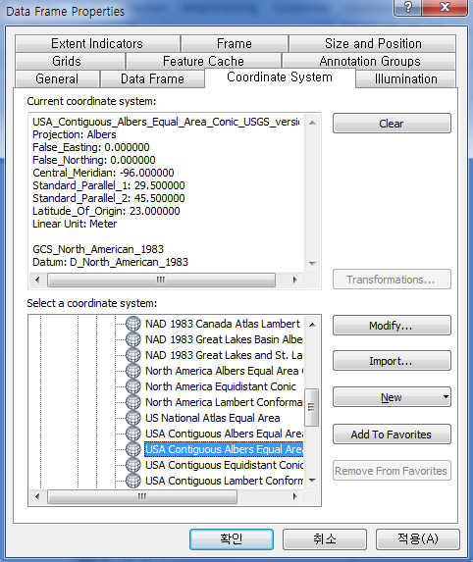

1. a. Add **Cntry94.shp** on the data frame. Click ‘Close’ button in Geographic Coordinate Systems Warning window.   
   b. Add **circles_NAD83.shp** to the same data frame. Move the circles layer above the country layer in the TOC.
2. Adjust the colors of the layers and add grids to follow the previous map symbology. To do so, open **Data Frame Properties** window as you did for adding the measured grid. Only this time, in **Grids and Graticules Wizard** window, check the circle next to “Graticule: divides map by meridians and parallels” to add a graticule. Click Next, then change the **Style** symbol to a blue color. Click Next in the Create a Graticule box, then click Finish and OK. If you see a **Warning window**, just click Yes. Change your view mode to **Layout View**. Your new graticule should appear in the layout view of your map.  
     
   You should get something that looks similar with the figure below for the Albers Equal Area projection.

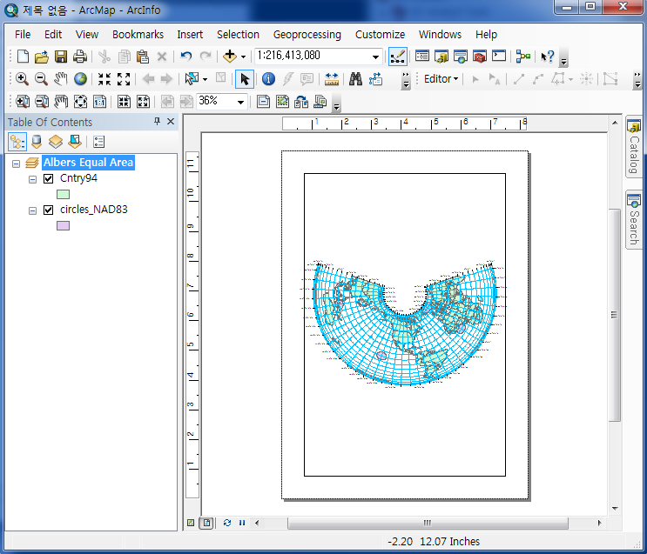

To make a more complete map than the current map, you should add other basic map elements including a legend, title, scale bar, author’s name, data source, and explanatory texts describing the projection used in the map. Refer your previous course materials for cartography or mapping or other external materials such as ArcGIS Help or Support website of ESRI (<http://support.esri.com>), if necessary. When you have a finished map product save your map design information (location, size, color, etc of objects in your map such as grids, map title, scalebar, or etc) by clicking **File>Save As…** menu or the corresponding icon. Give a name of your **.mxd** file when saving it.

Make sure that your map is in Layout View mode and export your map as a **PNG** image file with at least 300 DPI resolution from ArcMap by using File > Export Map… menu. To define the resolution, look at the Options section in the Export Map window.

|  |
| --- |
| **Question 4.** What kind of distortion is occurring in this display and what is preserved?  **(3 points)** |
|  |
| **Question 5**. In your map made from steps 15-18 include map elements such as: a title, legend, and texts **INSIDE** the border of the map. Use **Insert** menu in ArcMap to include those elements. (**6 points** for the map…must have all basic elements—**title, legend, author’s name, date of map production, data sources, explanatory texts, etc.**—to get full credits. However, **be careful** to insert appropriate map elements for the particular projection in your map.)  **Tips:** For example to add an explanatory text in layout view, go to the main menu of ArcMap and **Insert>Text** in the **Layout View** mode. A text box will appear on your map. You can start typing in this small box by double clicking on it. This will bring up the text properties box. Start typing and adjust the font color and size if you wish to suit the space you have on your map. |

1. In ArcMap, make a new map and rename the data frame as **Lambert Conformal**.
2. a. Change the data frame into the **North America Lambert Conformal Conic** projection. b. Add **Cntry94.shp.**
3. Add the Tissot Indicatrix circle layer, **circles_NAD83.shp**.
4. In ArcMap, make a new map and rename the data frame as **South Pole Azimuthal**.
5. a. Change the data frame into the **South Pole Azimuthal Equidistant** projection.   
   b. Add **Cntry94.shp.**
6. Add the Tissot’s Indicatrix circle layer, **circles_NAD83.shp**.

Now you can give it a try on your own.

(You do not need to include maps for 19-24 in your assignment.)

* **Define projection or Projection?**

Suppose that you have downloaded a dataset from a website and unfortunately, the dataset does not have any projection information included for some reason. However, you found descriptions of the dataset from the website and it provides what projection was used to make the dataset (let’s assume that). To use the dataset for your mapping properly, you need to include projection information to the dataset. Let’s learn how to process in the following.

1. Read the PDF document entitled “**Define projection_Project.pdf**” uploaded to the Lab1 folder on the Beachboard and understand the differences between two methods, “Define projection” and “Project”. FYI, the document was printed from one of technical articles at the [support.esri.com](http://support.esri.com/technical-article/000006790) website.
2. Open a new ArcMap and add the data **STATES_define_prj_1**. You will see “Unknown Spatial Reference” window opens. Read the message in the window and understand the situation of the data added to continue. Click OK.
3. Open the Layer Properties window of the data just added. Click on Source tab in the Layer Properties window. What information do you see from the Coordinate System section? Think about why such information is shown in the section.
4. Define projection of the data using Define Projection (Data Management) tool of ArcGIS (you may want to use Search tab at the right side of the ArcMap interface to find the tool). To figure out what projection should be defined to the data, **STATES_define_prj_1**, refer the projection information in **STATES_Lambert** data. To find information, open a new ArcMap and add **STATES_Lambert** and open Layer Properties > Source tab. FYI, if you add the other data to the current ArcMap the comparison cannot be made properly due to on-the-fly projection function of ArcMap. Locate the same projection in Define Projection window and apply it to **STATES_define_prj_1** data by clicking OK button.
5. Open Layer Properties > Source tab of the **STATES_define_prj_1** data and find projection information just added.
6. Let’s transform the data by projecting it to other projection. Open Project (Data Management) tool from ArcMap and choose the **STATES_define_prj_1** as the input data. Give the new file name (i.e., **STATES_define_prj_1_prj**) and location in Output Dataset of Feature Class. Choose **USA_Contiguous_Albers_Equal_Area_Conic_USGS** projection from Projected Coordinate Systems > Continental > North America folder for Output Coordinate System section of the tool. Click OK.
7. Open a new ArcMap and add **STATES_define_prj_1_prj** data and see how the data has changed from the projection procedure.

From now on, let’s compare the results of step 31 with another procedure.

1. Open a new ArcMap and add **STATES_define_prj_2** from Lab1 dataset. It also does not have any projection information for some reason. This time, you will not define the projection of the data and just try to project the data. Using the Project (Data Management) tool from ArcMap and choose the data **STATES_define_prj_2** as the input. What happens in the Project window?

|  |
| --- |
| **Question 6.** Provide the screenshot of your ArcMap showing the resulting map of Step 31.  **(4 points)**.  **Question 7.** Describe why you see the message from Project window as the results of Step 32. **(4 points).**  **Question 8.** Let’s assume that you have data with a projection “A” (i.e., Lambert Conformal Conic) and want to re-project the data to projection “B” (i.e., Albers Equal Area). To project the data, what method should you use between *define projection* and *project*? **(2 points)** Why do you think so? **(3 points)** |
|  |

**Part 4. Projection dependent operations**

1. In ArcMap, make a new map and add **STATES_Lambert.shp**. Now open the attribute table of the layer by right-clicking the layer name and clicking Open Attribute Table menu. In the attribute table, look at the **AREA_CON** field. The records in the field mean the areas of each state in the Lambert projection.
2. Add **STATES_Albers.shp** in ArcMap. Now open the attribute table of the STATES_Albers layer and look at the **AREA_EQL** field. These are the areas of each state in the Albers projection.

|  |  |  |  |  |  |  |  |  |  |  |  |  |  |  |  |
| --- | --- | --- | --- | --- | --- | --- | --- | --- | --- | --- | --- | --- | --- | --- | --- |
| **Question 9.** Compare the areas for the four-selected states—Colorado, Indiana, North Dakota, and Tennessee—in the two projections by entering the calculated area values in the Table 1 below (make a similar table in your lab report. Don’t forget to include a table number and a caption as below in your write-up). **Beware of the units in the table!**  **(8 points)**  (Hint: note that in the table it asks for answers in **kilometers squared**, and in the attribute table for the two projected files the linear units are not kilometers. This means you will have to do some **basic conversions** using your knowledge and any resources of the metric system.)  Table 1. Comparison of the areas for four-selected states and projections   |  |  |  | | --- | --- | --- | |  | Lambert Conformal Areas (km2) | Albers Equivalent Areas (km2) | | Colorado |  |  | | Indiana |  |  | | North Dakota |  |  | | Tennessee |  |  | |

This is the end of the Lab1. Good job! Remember that adding projections and knowing the different types of distortions are very important in GIS and cartography.

**Lab Deliverables:**

In the lab report please answer Questions 1 through 9 in a MS Word file and include the map for part 3. **Please do NOT directly insert your answers to this lab instruction.** **Use a separate document for your lab report**.

FYI, when you write-up your lab1 assignment, you can **insert the image into your Word document** by using **Insert tab > Picture button** in MS Word. Submit your completed lab report in electronic format to the BeachBoard “Lab1” dropbox by the beginning of lab2.

Any questions or concerns should be addressed to Hyowon at [hyowon.ban@csulb.edu](mailto:hyowon.ban@csulb.edu).